Lab - Managing System Files in Windows
- Introduction
In this lab, you will use Windows utilities to gather information about the computer.
- Recommended Equipment
- A computer running Windows
  - Customize the Start Menu in Windows.
    - Log on to the computer as an administrator.
Note: If you are using Windows 8, skip to Step 2.
    - To add Run to the Start menu, right-click Start and select Properties > Start Menu tab > Customize….
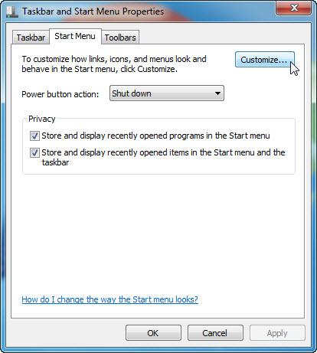
    - Scroll down until you see the Run command. Click in the box next to select the Run command and click OK.
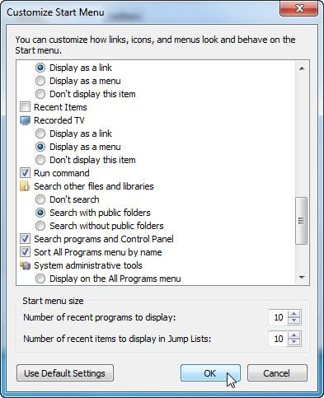
    - Click Apply > OK to close the Taskbar and Start Menu Properties window.
  - Review the System Information.
    - Open System Information by clicking Start > Run and type msinfo32. Click OK.
Note: In Windows 8, search for msinfo32 by using the Search Charm.
    - Click the plus sign next to Hardware Resources, Components, and Software Environment. Expand the window so you can see all the content.
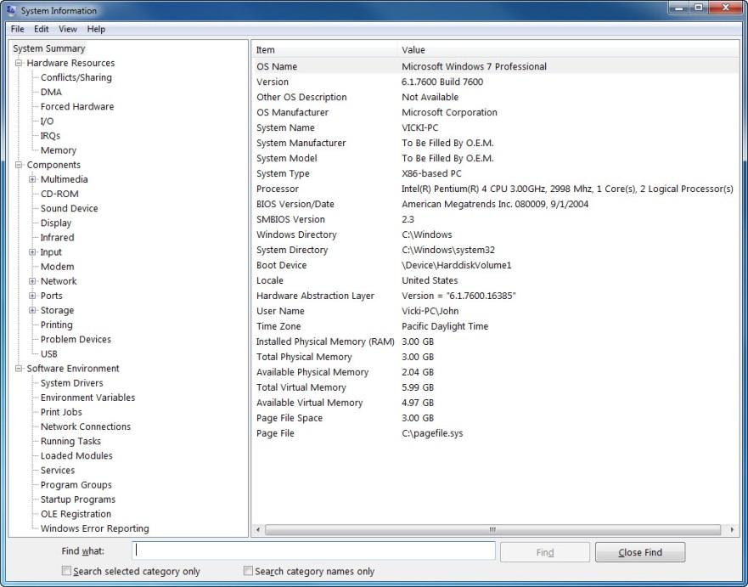
    - Under the System Summary heading locate and list the following:
Processor: Intel(R) Pentium(R) 4 CPU 3.00GHz, 2998 Mhz, 1 Core(s), 2 Logical Processor(s)
BIOS Version/Date: American Megatrends Inc. 080009, 9/1/2004
Total Physical Memory: 3.00 GB
    - Under the Hardware Resources heading, locate and list the following:
DMA channels and the device using the resources.
Channel 2 Standard floppy disk controller
Channel 4 Direct memory access controller
    - Under the Components heading and Software heading look around to see what information is provided in these areas.
    - Close the System Information window.
  - Review the System Configuration.
    - Open System Configuration by clicking Start > Run, and type msconfig. Click OK.
Note: In Windows 8, search for msconfig by using the Search Charm.
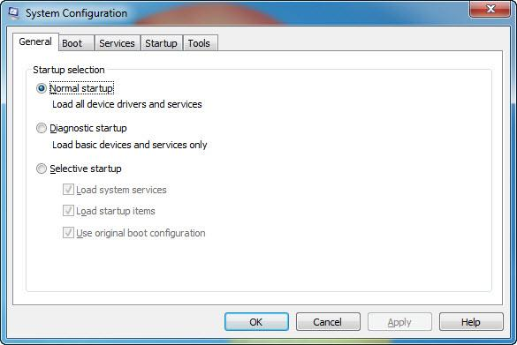
Note: Do not make any changes in this utility without instructor permission.
    - Click the General tab.
What are the startup options?
Normal startup, Diagnostic startup, or Selective startup.
    - Click the Boot tab. This tab is for modifying boot options.
    - Click the Services tab. This tab lists the computers services and status.
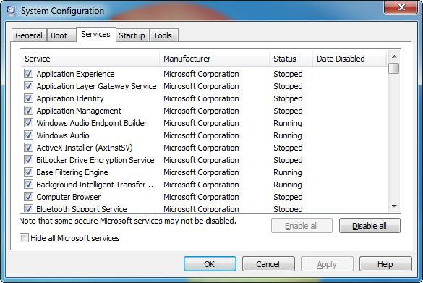
Can you enable and disable services at this tab?
Yes
    - Click the Startup tab. This tab lists the programs that are automatically loaded every time you turn on your computer.
Note: In Windows 8, the Startup tab indicates that the Task Manager is used to manage startup items. There is also a link to Startup tab of the Task Manager on this tab.
    - Click the Tools tab.
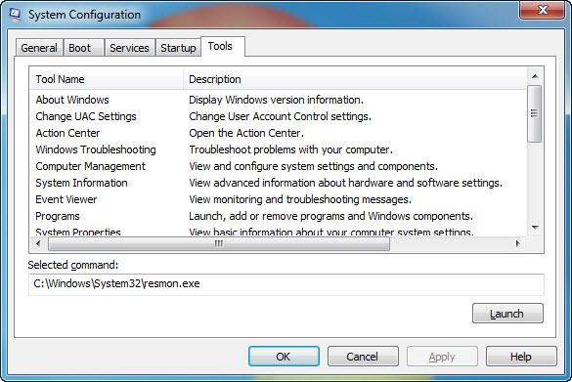
What can you do in this tab?
Launch Windows built-in utilities.
    - Click Cancel to close the System Configuration window.
  - Review DirectX Diagnostics.
    - Open the DirectX Diagnostic Tool by clicking Start > Run, and type dxdiag. Click OK.
Note: In Windows 8, search for dxdiag by using the Search Charm.
    - If you are asked to have DirectX check driver signatures, click No.
Note: When the DirectX Diagnostic Tool first opens, it may take a minute to load all information. Your DirectX Diagnostic Tool may not appear exactly as shown in this lab.
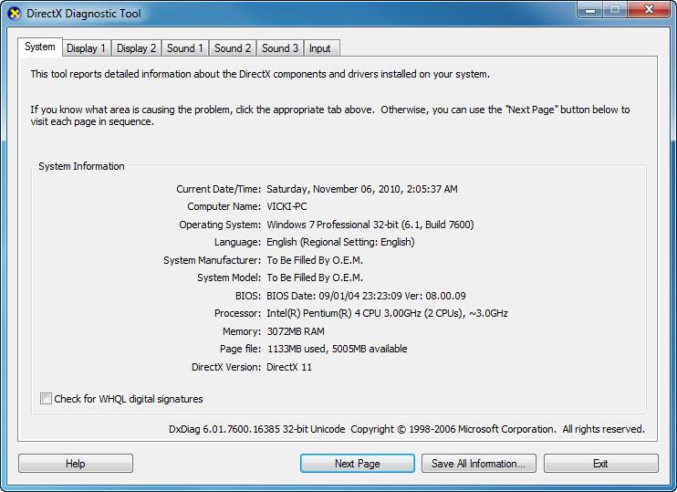
    - Make sure the System tab is active.
What does this tool report?

    - Click Next Page until you are at the Display tab.
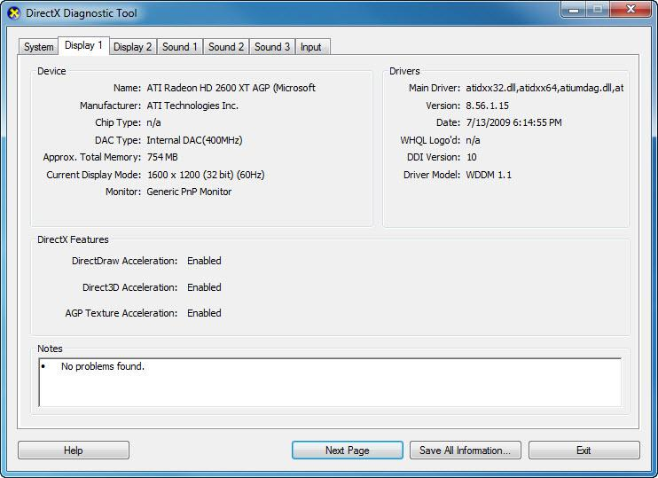
What information is listed on this page?
Devices, Drivers, and DirectX Features
    - Click Next Page until you are at the Sound tab.
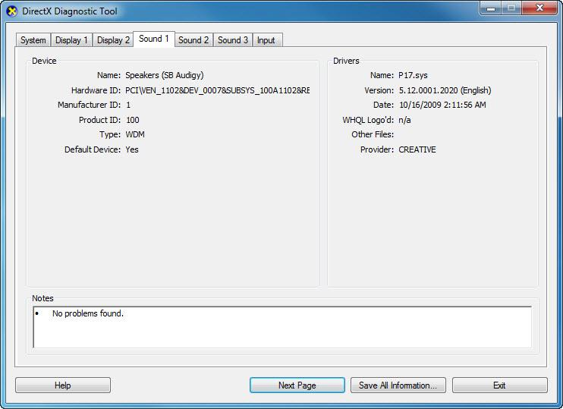
What information is listed on this page?
Devices and Drivers
    - Click Next Page until you are on the Input tab.
What information is listed on this page?
Input devices
    - Click Exit.
- Reflection
  - Why would it be beneficial to turn off a service in the system configuration?
It may be beneficial to turn off a service if that service may have become unresponsive, or if a service is using too many resources.
  - When would you use the startup tab of the system configuration tool?
There may be programs that you do not wish to start when the computer boots.

